User Interface

Screen Saver Page

This page is displayed when the kiosk is idle and shows advertisements to customers prior to their using the kiosk to initiate a rental.
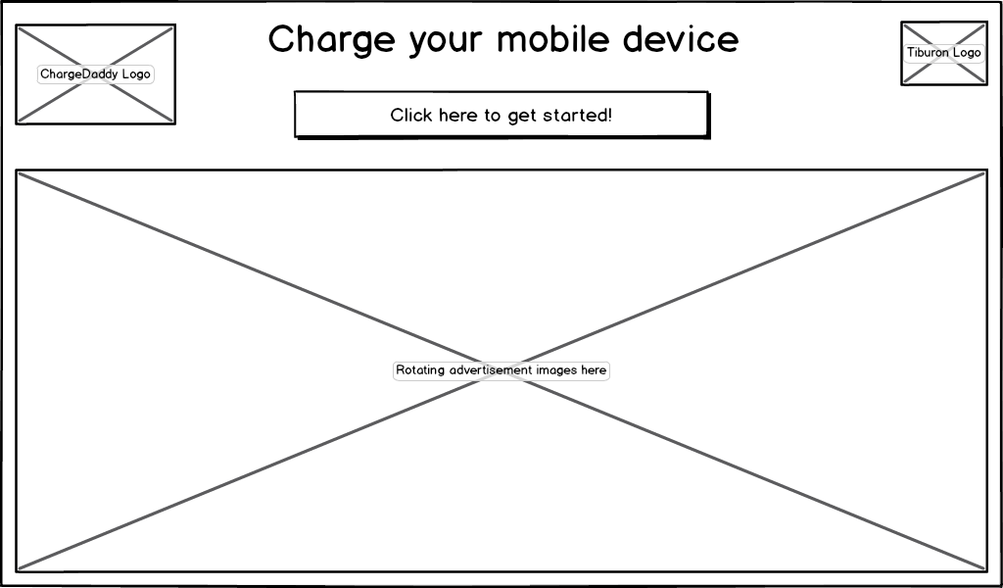
Figure 1: Screen Saver page

Action: | Display the Screen Saver
Pre-Conditions: | The kiosk has been configured to display the screen saver on the Configure Advertising Page.
Events: |  | Any page (see exceptions) is idle for the configurable timeout period as configured in Kiosk Timeouts Tab.
 |  | The title reads “Charge your mobile device” if the kiosk is configured as the ChargeDaddy product, otherwise it reads “Store your items”.
 |  | The screen saver displays each image for n seconds (admin configurable) and then shows the next image.
 |  | The user taps the screen to dismiss the screen saver.
Exceptions: | - Must not occur on the following pages: “Deposit Additional Bills”; “Choose PIN”; “Retrieval Acknowledgment”.  - If there are no images found to rotate through, the screen saver is hidden and if configured the System Messages Page is displayed instead.
Assumptions: | The Tiburon installation technician has placed images into a directory the screen saver uses to look for images.

System Message Page

This page is displayed when the venue or Tiburon wishes to display a message to users prior to their use of the kiosk.
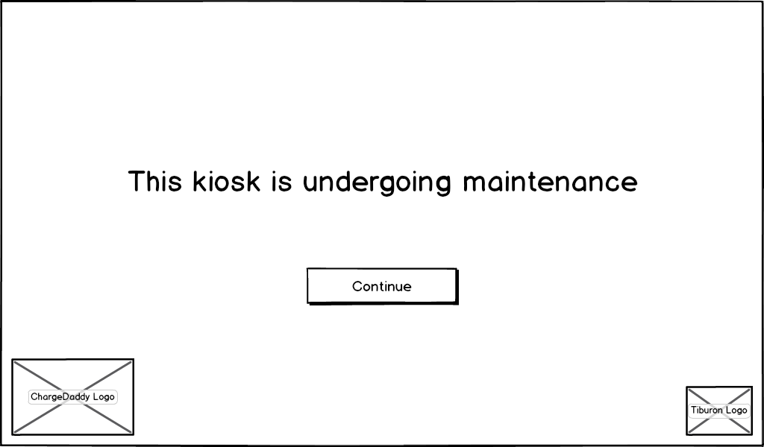
Figure 2: System Messages page

Action: | Displaying a System Message
Description: | Occurs when a system message is configured to be displayed.
Pre-Conditions: | A system message must have been configured using the System Messages Page.
Events: |  | The system is idle for the configurable timeout period as configured in Kiosk Timeouts Tab and no Screen Saver is configured, or the Screen Saver Page is dismissed by the user.
 |  | The system displays the configured system message’s text.
 |  | The user clicks the “Continue” button to display the Home Page.
Alternate Path: | Message Configured to Require Kiosk User Login
 |  | The system message was configured to require login as an administrative user of the kiosk using an access code PIN using the System Messages Page.
 |  | The system displays the configured system message’s text.
 |  | The “Continue” button is hidden as the message cannot be dismissed by a renter.
 |  | The user taps the four corners of the screen as configured on the Kiosk Security Tab.
 |  | The system displays the Admin Login Page.
 |  | The user logs into the kiosk using a valid administrative user access code PIN. The user must be any valid user, a user in the Venue Administrator role, or a user in the Tiburon Administrator role depending on the configuration of the message in the System Messages Page.
 |  | The Administrative Home Page displayed.
Alternate Path: | No System Messages Configured
 |  | The Home Page is displayed.
Notes: | If the kiosk is part of a floated rental configuration, use the database from the kiosk pointed to for floating to determine what message to display.

Action: | Any Page Times Out
Description: | Occurs when the user doesn’t interact with a page (see exceptions) within a timeout period.
Events: |  |  | The user leaves the page idle for the number of seconds configured in the “Time to make selections” setting on the Kiosk Timeouts tab.
 |  |  | The system displays the Screen Saver Page.
Exceptions: |  | - Must not occur on the following pages: “Deposit Additional Bills”; “Choose PIN”; “Retrieval Acknowledgment”.

Home Page

The home page is displayed when the user has dismissed the screen saver and any system messages and desires to begin using the kiosk to rent or retrieve the contents of a locker or compartment from a prior rental.
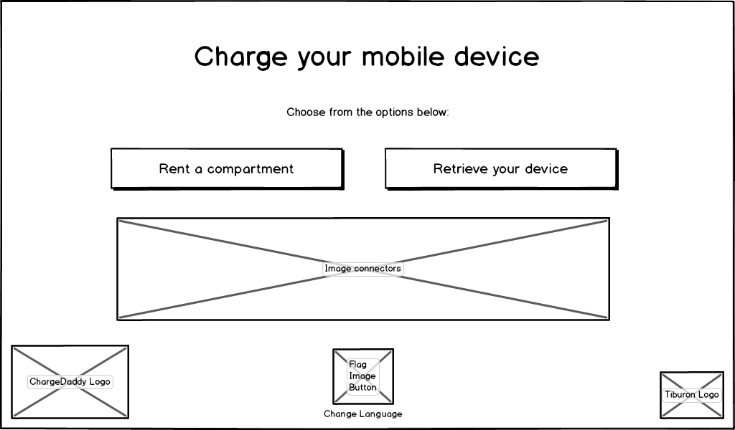
Figure 3: ChargeDaddy Home page

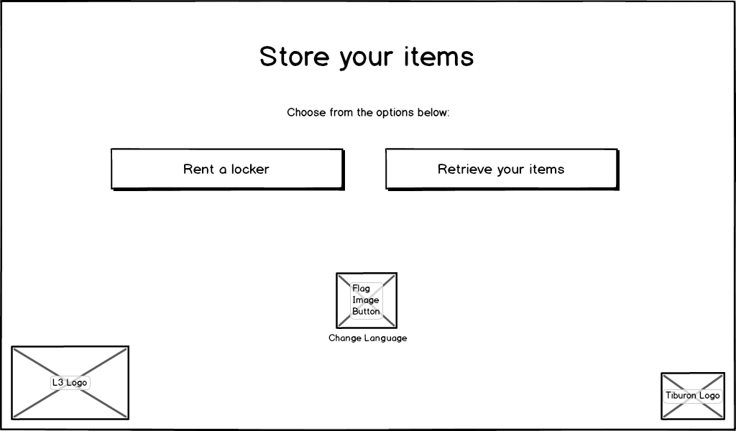
Figure 4: Electronic Locker Home page

Action: | Displaying the Home Page
Description: | Occurs when the user dismisses the Screen Saver or System Message Pages if configured.
Pre-Conditions: | Another page in the application has become idle for the configurable timeout period as configured in Kiosk Timeouts Tab, or the user was at the System Messages page and dismissed it to continue.
Events: |  | The system displays strings in the user interface in the language that is configured by the “Default Language” setting of the kiosk on the Add/Edit Kiosk Page unless it has been changed by the user through the Select Language page for this session.
 |  | If the kiosk is configured to be an express station via the Express Station Settings page, the “Rent a compartment/locker” button is not available (the user may not rent, only retrieve).
 |  | The title says “Charge your Mobile Device” if the kiosk is configured as the ChargeDaddy product, or “Store your items” if the kiosk is configured as the Electronic Locker product.
 |  | The rent button says “Rent a compartment” if the kiosk is configured as the ChargeDaddy product, or “Rent a locker” if the kiosk is configured as the Electronic Locker product.
 |  | The retrieve button says “Retrieve your device” if the kiosk is configured as the ChargeDaddy product, or “Retrieve your items” if the kiosk is configured as the Electronic Locker product.
 |  | The change language button displays a flag for the primary nationality that the home page is set to. By default it is set to English and so will show the U.S. flag.
Exceptions: | - If there are no lockers or compartments available the screen should display one of the following messages:  1) Sorry, all lockers are sold out. Please try again later.  2) Sorry, lockers in this bank are sold out. Please try our other banks within the venue.

Select Language Page

This page is displayed when the user wishes to change the language that the user interface will be displayed in during their session of using the kiosk.
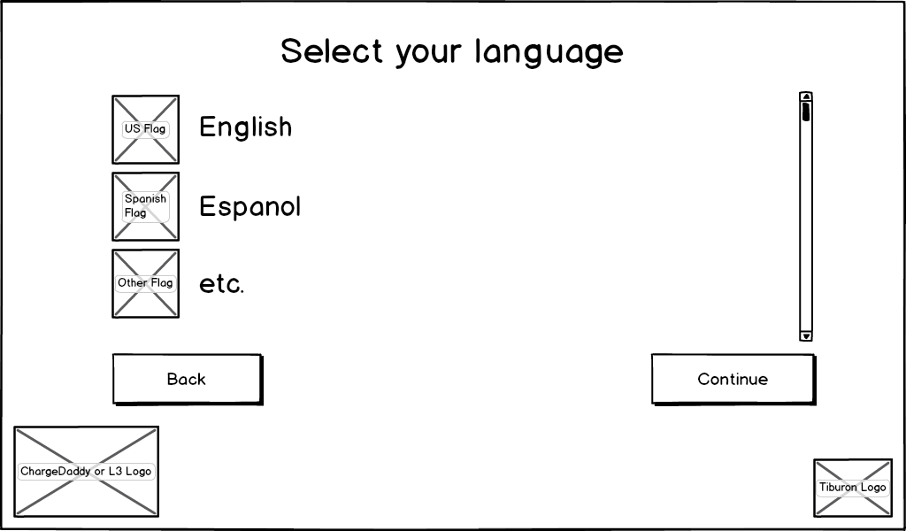
Figure 5: Select Language page

Action: | Displaying the Change Language Page
Description: | Occurs when the change language page is first displayed.
Events: |  | The list of languages displays an image for the primary nationality of each language available to translate the application into. It also displays the name of the language in that native language (English, Espanol etc.) next to each flag.
 |  | The Continue button is initially disabled.

Action: | Navigating to the Home Page
Description: | Occurs when the back button is clicked.
Events: |  | The user clicks the Back button.
 |  | The Home Page appears.

Action: | Changing the Language
Description: | Occurs when the Continue button is clicked.
Events: |  | The user selects a language from the list.
 |  | The user clicks the Continue button.
 |  | The Home Page appears translated into the selected language with the Change Language button and image on that page updated to reflect the selection. All successive rental-related (non-Administrative) pages will display in the selected language until a page times out and causes returning to the Home Page, or the user completes a rental or retrieval process and returns to the Home Page.

Action: | The Page Times Out
Description: | Occurs when the user doesn’t interact with the page within a timeout period.
Events: |  | The user leaves the page idle for the number of seconds configured in the “Time to make selections” setting on the Kiosk Timeouts tab.
 |  | The system displays the Screen Saver Page.

Select Compartment Type Page

This page is displayed when the user needs to decide what type of compartment they wish to rent.
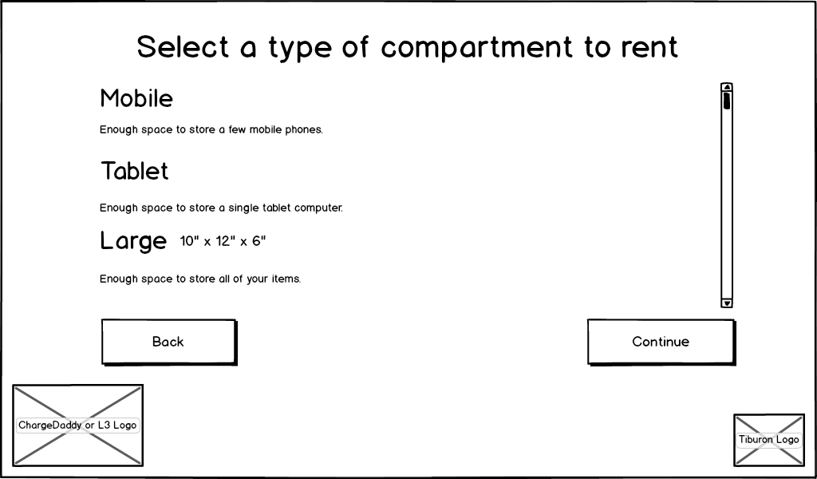
Figure 6: Select Compartment Type page

Action: | Displaying the Select Compartment Type Page
Description: | Occurs when the select compartment type page is first displayed.
Events: |  | The list of types of compartments is listed for each one configured in the List Compartment Types page of the Administrative website. Each entry lists the name and description of the compartment type, and if there were values provided for the width, depth, and height these will be listed (interpreted as inches) next to the name.
 |  | The Continue button is disabled.

Action: | Navigating to the Home Page
Description: | Occurs when the back button is clicked.
Events: |  | The user clicks the Back button.
 |  | The Home Page appears.

Action: | Selecting the Compartment Type
Description: | Occurs when the Continue button is clicked.
Events: |  | The user selects a Compartment Type.
 |  | The user clicks the Continue button.
 |  | The Select Rental Type page appears. All successive rental pages that show pricing or options sensitive to the Compartment Type use this selection to reflect that information.

Action: | The Page Times Out
Description: | Occurs when the user doesn’t interact with the page within a timeout period.
Events: |  | The user leaves the page idle for the number of seconds configured in the “Time to make selections” setting on the Kiosk Timeouts tab.
 |  | The system displays the Screen Saver Page.

Select Rental Type Page

This page is displayed when the user needs to decide what type of rental they wish to choose.
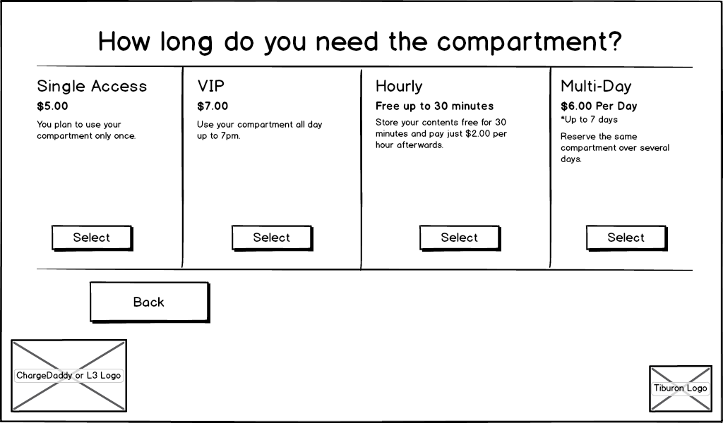
Figure 7: Select Rental Type page

Action: | Displaying the Select Rental Type Page  (see file “Pricing Matrix - Rental Types & Charges Vm.n .xlsx” for Rental Type parameters)
Description: | Occurs when the select rental type page is first displayed.
Events: |  | The list of permitted rental types is listed for each one configured in the Kiosk Pricing Tab for the current kiosk using the Administrative website.
 |  | The price formatted in the currency as configured on the Kiosk Pricing Tab is displayed for each Rental Type as displayed in the mockup.
 |  | The number of minutes that customers have to use an hourly compartment before they are charged as configured on the Kiosk Pricing Tab is displayed for the Hourly Rental Type as displayed in the mockup.
 |  | The maximum number of days that a customer may have a multi-day rental is displayed as configured on the Kiosk Pricing Tab for the Multi-Day Rental Type as displayed in the mockup.
Alternate Path: | Kiosk Configured in Complimentary Rental Mode
 |  | The kiosk was configured in the Add/Edit Kiosk page to have its Rental Mode set to “Complimentary”.
 |  | The page is skipped and instead the Authorize Payment Page is displayed. All future pages that are sensitive to the Rental Type selected operate as though a Single Access Rental Type was selected.

Action: | Navigating to the Select Compartment Type Page
Description: | Occurs when the back button is clicked.
Events: |  | The user clicks the Back button.
 |  | The Select Compartment Type page appears.

Action: | Selecting the Rental Type
Description: | Occurs when the Select button under a Rental Type is clicked.
Events: |  | The user clicks the Select button below a rental type.
 |  | The Authorize Payment Page appears. All successive rental pages that show information or behave sensitive to the Rental Type use this selection.

Action: | The Page Times Out
Description: | Occurs when the user doesn’t interact with the page within a timeout period.
Events: |  | The user leaves the page idle for the number of seconds configured in the “Time to make selections” setting on the Kiosk Timeouts tab.
 |  | The system displays the Screen Saver Page.

Authorize Payment Page

This page is displayed when the user must authorize payment before accessing a compartment or locker for rental.
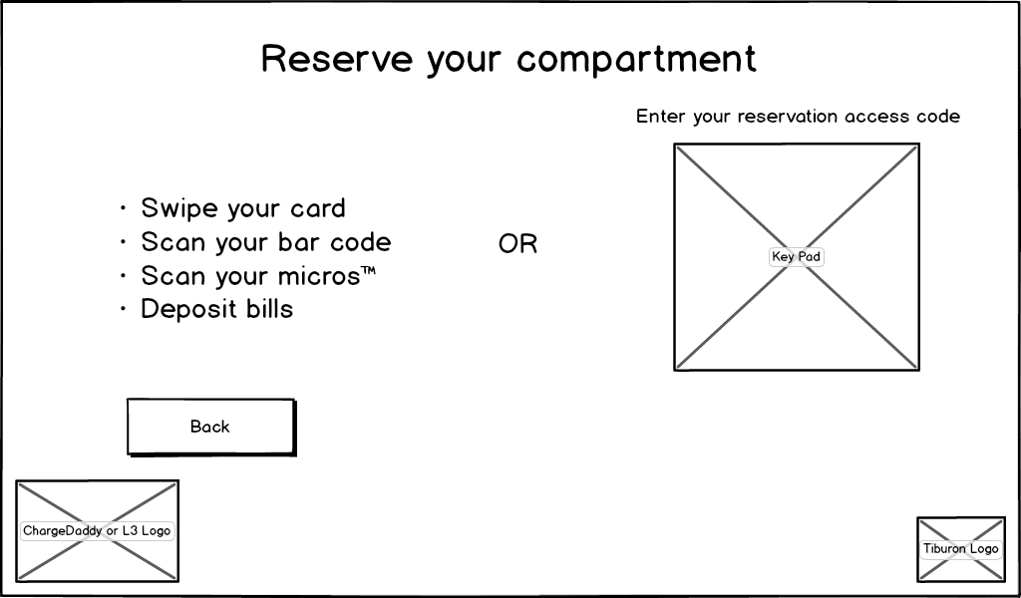
Figure 8: Authorize Payment page

Action: | Displaying the Authorize Payment Page
Description: | Occurs when the authorize payment page is first displayed.
Events: |  | The list of permitted hardware means of authorizing a payment is displayed in a list on the left side of the page. This list is configured using the Kiosk Payment & Retrieval Tab of the Administrative website.
 |  | If the renter selected “Multi-Day” or “Hourly” as the rental type in the previous screen, the “Deposit Bills” (bill acceptor payment method) will not be available.
 |  | A keypad control is displayed on the right side of the screen allowing the customer to enter any access code imported into the kiosk through the Kiosk Access Codes Tab of the Administrative website.

Action: | Renter Swipes a Credit Card
Description: | Occurs when the renter swipes a credit card.
Pre-Conditions: | The system must have been configured using the Kiosk Payment & Retrieval Tab to allow credit cards to be used to rent.
Events: |  | The renter swipes a credit card using the MagTek credit card reader.
 |  | The system displays the Choose PIN Page.
Alternate Path: | Duplicate rental attempt
 |  | The card the user swiped is already being used to rent a compartment.
 |  | The system displays the Duplicate Rental Page.

Action: |  | Renter Scans a Bar Code
Description: |  | Occurs when the renter scans a bar code.
Pre-Conditions: |  | The system must have been configured using the Kiosk Payment & Retrieval Tab to allow bar codes to be used to rent.
Post-Conditions: |  | None
Events: |  |  |  | The renter scans a bar code using the bar code scanner.
 |  |  |  | The system displays the Choose PIN Page.
Alternate Path: |  | Duplicate rental attempt
 |  |  |  | The bar code the user swiped is already being used to rent a compartment.
 |  |  |  | The system displays the Duplicate Rental Page.
Action: |  | Renter Scans a 3rd Party POS code or card (ex. Micros)
Description: |  | Occurs when the renter scans a POS.
Pre-Conditions: |  | The system must have been configured using the Kiosk Payment & Retrieval Tab to allow Micros (or other 3rd party) POS to be used to rent.
Events: |  |  |  | The renter scans a Micros (or other 3rd party) POS using a scanner.
 |  |  |  | The system displays the Choose PIN Page.
Alternate Path: |  | Duplicate rental attempt
 |  |  |  | The POS the user scanned is already being used to rent a compartment.
 |  |  |  | The system displays the Duplicate Rental Page.
Action: | Renter Deposits a Bill
Description: | Occurs when the renter deposits a bill for payment.
Pre-Conditions: | The system must have been configured using the Kiosk Payment & Retrieval Tab to allow cash a bill acceptor to be used to rent.
Events: |  |  | The renter deposits a bill into the configured hardware bill acceptor.
 |  |  | The system displays the Choose PIN Page.
Alternate Path: | Insufficient bill deposited
 |  |  | The amount of the bill deposited is insufficient to cover the cost of the rental.
 |  |  | The system displays the Deposit Additional Bills Page.

Action: | Renter Submits a Reservation Access Code
Description: | Occurs when the renter uses the key pad to submit a reservation access code for rental.
Events: |  | The renter enters an access code into the keypad and submits it using the Enter button.
 |  | The system displays the Open Compartment Page.
Alternate Path: | Invalid code entered
 |  | The reservation access code was not recognized in the list of access codes configured using the Kiosk Access Codes Tab of the Administrative Website for this kiosk.
 |  | The key pad control notifies the user that an invalid code was entered.
Alternate Path: | Duplicate rental attempt
 |  | The access code entered is already being used to rent a compartment.
 |  | The system displays the Duplicate Rental Page.

Action: | Navigating to the Select Rental Type Page
Description: | Occurs when the back button is clicked.
Events: |  | The user clicks the Back button.
 |  | The Select Rental Type page appears. If the kiosk was configured using the Add/Edit Kiosk Tab to be in Complimentary Rental Mode, the Select Compartment Type Page appears.

Action: | The Page Times Out
Description: | Occurs when the user doesn’t interact with the page within a timeout period.
Events: |  | The user leaves the page idle for the number of seconds configured in the “Time to swipe cards or scan bar codes” setting on the Kiosk Timeouts tab.
 |  | The system displays the Screen Saver Page.

Duplicate Rental Page

This page is displayed when the user attempts to rent a locker or compartment using a credential (credit card etc.) that is already being used in an active rental.
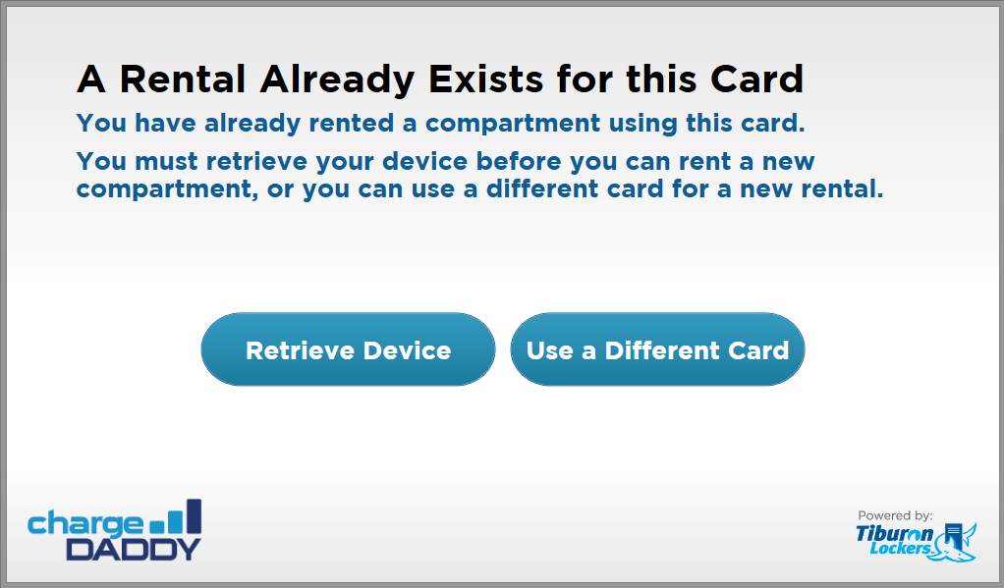
Figure 9: Duplicate Rental page

Action: | Displaying the Duplicate Rental Page
Description: | Occurs when the renter attempts to use the same payment source to rent a compartment as one that is already in use for another rental at the kiosk.
Events: |  | The retrieve button says “Retrieve Device” if the kiosk is configured to be the ChargeDaddy product, otherwise it says “Retrieve Items”.
 |  | The use a different source button says “Use a different card” if a credit card was swiped prior to displaying the page. If a bar code was used it says “Use a different bar code”. If a Micros (or other 3rd party) POS was used it says “use a different form of ID”. If an access code was used it says “Use a different access code”.

Action: | Renter Initiates Retrieval of Device
Description: | Occurs when the renter clicks the retrieve button.
Events: |  | The renter clicks the retrieve button.
 |  | The system displays the Lookup Rental page.

Action: | Renter Initiates Renting another Compartment
Description: | Occurs when the rent button is clicked.
Events: |  | The user clicks the Rent button.
 |  | The Select Compartment Type page appears.

Action: | The Page Times Out
Description: | Occurs when the user doesn’t interact with the page within a timeout period.
Events: |  | The user leaves the page idle for the number of seconds configured in the “Time to make selections” setting on the Kiosk Timeouts tab.
 |  | The system displays the Screen Saver Page.

Deposit Additional Bills Page

This page is displayed when the user must deposit additional bills to cover the cost of renting a compartment or locker.
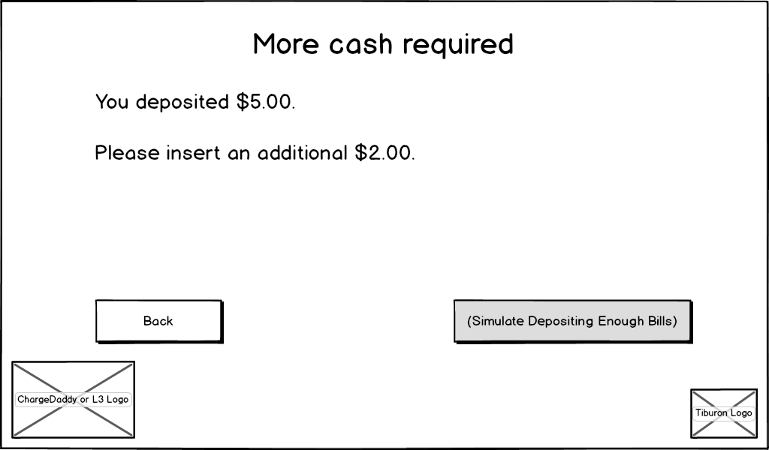
Figure 10: Deposit Additional Bills page

Action: | Displaying the Deposit Additional Bills Page
Description: | Occurs when the deposit additional bills page is first displayed.
Events: |  | The amount deposited with the first bill on the Authorize Payment Page is displayed in the currency as configured by the Kiosk Pricing Tab of the Administrative Website for this kiosk.
 |  | The difference between the amount entered initially and the total cost required to cover the rental options selected via the Select Rental Type page is displayed in the currency as configured by the Kiosk Pricing Tab of the Administrative Website for this kiosk.

Action: | Renter Deposits Additional Bills
Description: | Occurs when the renter deposits additional bills.
Events: |  | The renter deposits a bill large enough to cover the cost of the rental when combined with the amount already deposited.
 |  | The system displays the Choose PIN Page.
Alternate Path: | The bill was not large enough to cover the rental when combined with the amount already deposited
 |  | The fields on the page update to represent the total amount deposited combining all bills that were deposited as part of the rental
Alternate Path: | The page times out
 |  | The user leaves the page idle for the period configured in the Kiosk Timeouts Tab of the Administrative Website.
 |  | The system displays the Screen Saver Page.
Notes: | Every time you enter a bill the timeout restarts.

Action: | Navigating to the Authorize Payment Page
Description: | Occurs when the back button is clicked.
Events: |  | The user clicks the Back button.
 |  | The Authorize Payment page appears.

Action: | The Page Times Out
Description: | Occurs when the user doesn’t interact with the page within a timeout period.
Events: |  | The user leaves the page idle for the number of seconds configured in the “Time to swipe cards and scan bar codes” setting on the Kiosk Timeouts tab.
 |  | The system displays the Screen Saver Page.

Choose PIN Page

This page is displayed if the system is configured to allow the renter to choose a PIN they can use to access the compartment when they return.
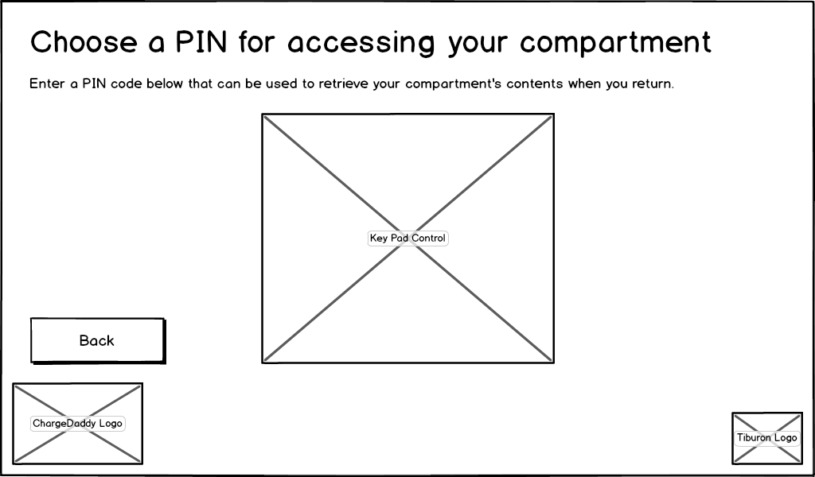
Figure 11: Choose PIN page

Action: | Displaying the Choose PIN Page
Description: | Occurs when the choose PIN page is first displayed.
Events: |  | The user enters a PIN code to use to retrieve the contents of their locker or compartment at a later time.
 |  | The system displays the Compartment Is Open Page.
Alternate Path: | The PIN code entered was not at least 5 digits in length
 |  | The user is notified through a popover dialog that the PIN must be at least 5 digits in length

Action: | Navigating to the Authorize Payment Page
Description: | Occurs when the back button is clicked.
Events: |  | The user clicks the Back button.
 |  | The Authorize Payment page appears.

Open Compartment Page

This page is displayed to notify the user that the component they have rented is open and instructs them to deposit their contents into the compartment to continue.
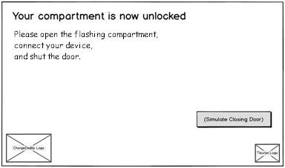
Figure 12a: Charge Daddy Open Compartment Page

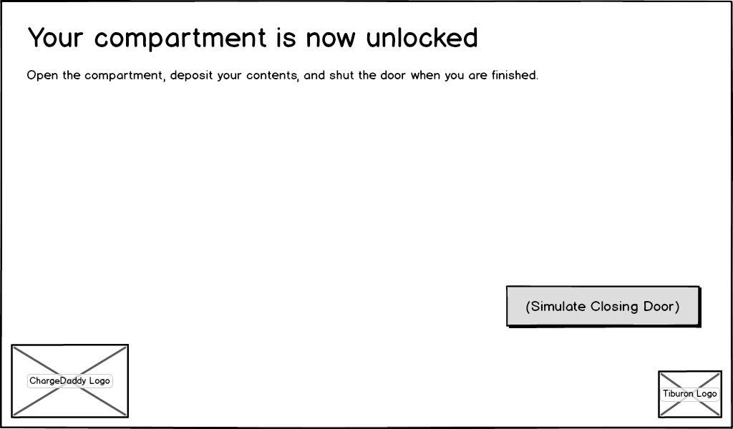
Figure 12b: Electronic Locker Open Compartment Page

Action: | Compartment Unlocked to Deposit Contents
Description: | This case occurs when the user navigates to this page during the rental process.
Pre-Conditions: | The renter initiated rental of their contents.
Events: |  | The page title reads “Your compartment is now unlocked” for ChargeDaddy and “Your locker is now unlocked” for the Electronic Locker.
 |  | The page instructions read “Open the flashing compartment, connect your device, and shut the door.” for ChargeDaddy and “Open the locker, deposit your contents, and shut the door when you are finished.” for the Electronic Locker.
 |  | The Rental Confirmation Page displayed.

Action: | Compartment Unlocked to Retrieve Contents
Description: | This case occurs when the user navigates to this page during the retrieval process.
Events: |  | The page title reads “Your compartment is now unlocked” for ChargeDaddy and “You locker is now unlocked” for Electronic Locker.
 |  | The page instructions read “Open the compartment, retrieve your contents, and shut the door when you are finished” for ChargeDaddy and “Open the locker, retrieve your contents, and shut the door when you are finished” for Electronic Locker.
 |  | The Rental End Page is displayed.

Action: | Administrative Cancel of Currently Active Rental
Description: | This function allows a Venue Admin or Tiburon Admin to cancel a currently active rental.
Pre-Conditions: | - Tiburon Admin or Venue Admin has “double-clicked” a row in the datagrid on the Rentals Page.
Events: |  | The page title reads “Your compartment is now unlocked” for ChargeDaddy and “You locker is now unlocked” for Electronic Locker.
 |  | The page instructions read “Open the compartment, retrieve your contents, and shut the door when you are finished” for ChargeDaddy and “Open the locker, retrieve your contents, and shut the door when you are finished” for Electronic Locker.
 |  | The system records that the rental was canceled. If payment was not collected during rental (hourly, multi-day) it will not be charged.
 |  | The Rental End Page is displayed.

Action: | The Compartment Is Never Opened
Description: | Occurs when the user doesn’t open the compartment within a timeout period.
Events: |  | The user leaves the page idle for the number of seconds configured in the “Time to open compartment” setting on the Kiosk Timeouts tab.
 |  | The user is notified that they have an additional number of seconds (as configured in the “Time to open compartment” setting) to open the compartment.
 |  | If the user does not open the compartment within the additional timeout period, the system displays the Screen Saver Page.
 |  | If the user does open the compartment within the additional timeout period – If the screen was displayed for rental, the system displays the Rental Confirmation Page if it was displayed for retrieval, it displays the Rental End Page.

Action: | The ChargeDaddy user keeps the door open to access their device
Description: | Occurs when the user doesn’t close the compartment within a timeout period.
Events: |  | The system displays (flashes?) the message “Please connect your device. You must close the compartment door to continue charging.”
 |  | The compartment color is changed from white to flashing red.
 |  | The charging circuit is disabled.

Action: | The compartment or locker is Never Closed
Description: | Occurs when the user doesn’t close the compartment within a timeout period.
Events: |  | The system continues to the Home Page.

Rental Confirmation Page

This page is displayed to confirm to the user that their rental was successfully started.
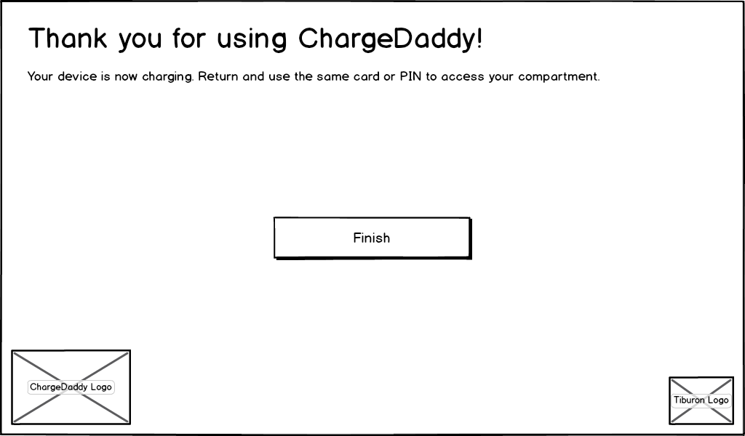
Figure 13: Rental Confirmation Page

Action: | Rental Confirmation Display Message
Description: | Occurs after the user comfirms renting a compartment
Pre-Conditions: | The user has proceeded through the rent a compartment/ locker steps beginning with the Home Page
Post-Conditions: | The compartment is no longer available for rental.
Events: |  | The description will reflect whether the compartment can be returned to in the future multiple times or not.
 |  | The user clicks the Finish button on this screen.
 |  | If a printer is configured, a receipt is printed in the language that the current session is set to.
 |  | The Screen Saver page is displayed.

Action: | The Page Times Out
Description: | Occurs when the user doesn’t interact with the page within a timeout period.
Events: |  | The user leaves the page idle for the number of seconds configured in the “Time to make selections” setting on the Kiosk Timeouts tab.
 |  | The system displays the Screen Saver Page.

Lookup Rental Page

This page is displayed to allow a renter to lookup their existing rental using the credit card or other authorization mechanism configured for the kiosk so they can retrieve the contents of the locker or compartment they rented.
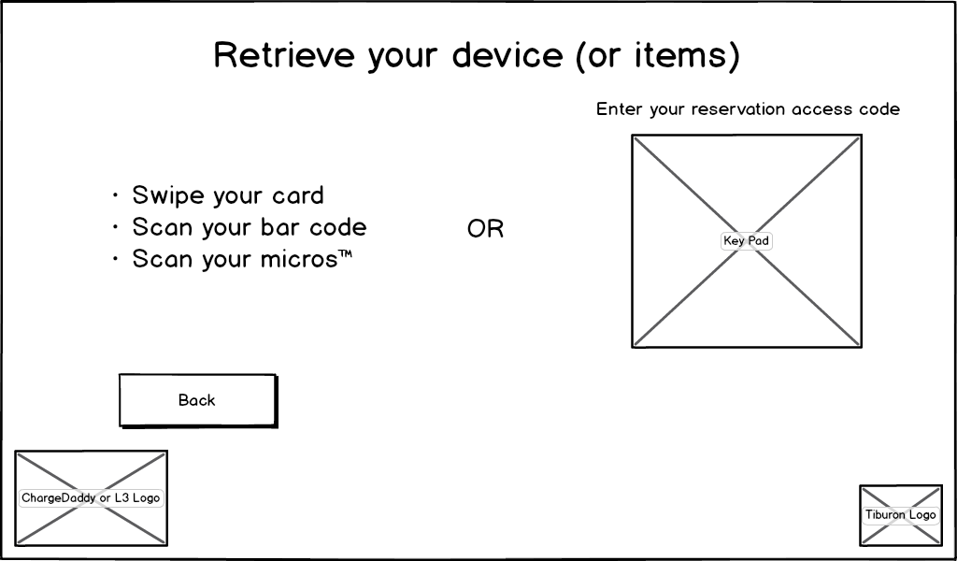
Figure 14: Lookup Rental page

Action: | Displaying the Lookup Rental Page
Description: | Occurs when the lookup rental page is first displayed.
Events: |  | The list of permitted hardware means of authorizing a payment is displayed in a list on the left side of the page. This list is configured using the Kiosk Payment & Retrieval Tab of the Administrative website.
 |  | A keypad control is displayed on the right side of the screen allowing the customer to enter any access code imported into the kiosk through the Kiosk Access Codes Tab of the Administrative website or created during rental when a PIN was chosen using the Choose PIN Page.

Action: | Renter Swipes a Credit Card
Description: | Occurs when the renter swipes a credit card.
Pre-Conditions: | The system must have been configured using the Kiosk Payment & Retrieval Tab to allow credit cards to be used to rent.
Events: |  | The renter swipes a credit card using the MagTek credit card reader.
 |  | The system looks for a rental that is for the same credit card.
 |  | If the rental was found, the Open Compartment Page is displayed.
Alternate Path: | Rental not found
 |  | The card the user swiped was not found as an existing rental.
 |  | The system notifies the user that no rental could be found with that card.

Action: | Renter Scans a Bar Code
Description: | Occurs when the renter scans a bar code.
Pre-Conditions: | The system must have been configured using the Kiosk Payment & Retrieval Tab to allow bar codes to be used to rent.
Events: |  | The renter scans a bar code using the bar code scanner.
 |  | The system looks for a rental that is for the same bar code.
 |  | If the rental was found, the Open Compartment Page is displayed.
Alternate Path: | Rental not found
 |  | The bar code the user swiped was not found as an existing rental.
 |  | The system notifies the user that no rental could be found with that card.

Action: | Renter Scans a Micros (or other 3rd party) POS
Description: | Occurs when the renter scans a Micros (or other 3rd party) POS.
Pre-Conditions: | The system must have been configured using the Kiosk Payment & Retrieval Tab to allow Micros (or other 3rd party) POS to be used to rent.
Events: |  | The renter scans a Micros (or other 3rd party) POS using a Micros scanner.
 |  | The system looks for a rental that is for the same bar code.
 |  | If the rental was found, the Open Compartment Page is displayed.
Alternate Path: | Rental was not found
 |  | The Micros POS the user swiped was not found as an existing rental.
 |  | The system notifies the user that no rental could be found with that card.
Action: | Renter Submits a Reservation Access Code
Description: | Occurs when the renter uses the key pad to submit a reservation access code for retrieval.
Events: |  | The renter enters an access code into the keypad and submits it using the Enter button.
 |  | The system checks whether a rental exists for that access code.
 |  | If the access code was found, the Open Compartment Page is displayed.
Alternate Path: | Invalid code entered
 |  | The reservation access code was not recognized in the list of access codes configured using the Kiosk Access Codes Tab of the Administrative Website for this kiosk or created during rental.
 |  | The key pad control notifies the user that an invalid code was entered.
Alternate Path: | Rental not found for access code
 |  | The user is notified that the access code is invalid.

Action: | Navigating to the Home Page
Description: | Occurs when the back button is clicked.
Events: |  | The user clicks the Back button.
 |  | The Home Page appears.

Action: | The Page Times Out
Description: | Occurs when the user doesn’t interact with the page within a timeout period.
Events: |  | The user leaves the page idle for the number of seconds configured in the “Time to swipe cards or scan bar codes” setting on the Kiosk Timeouts tab.
 |  | The system displays the Screen Saver Page.

Retrieval Acknowledgement Page

This page is displayed to require the user to acknowledge their responsibility for removing the contents of the compartment or locker to disclaim Tiburon from legal responsibility in the event that they fail to remove the contents.
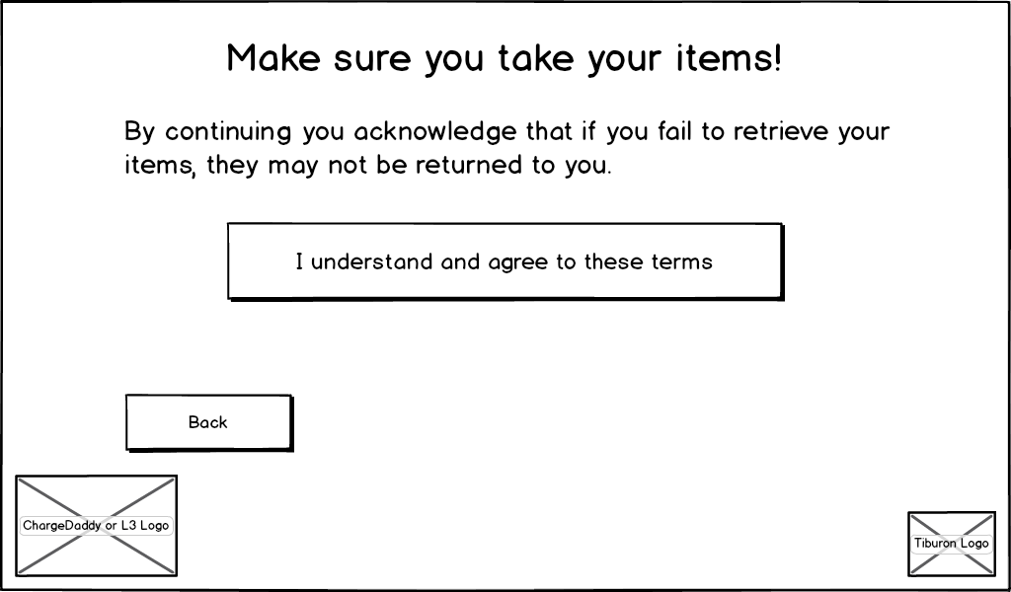
Figure 15: Retrieval Acknowledgement page

Action: | Acknowledging retrieval of contents
Description: | Occurs after the user looks up an existing rental to retrieve their contents
Events: |  | The user clicks the “I agree” button.
 |  | The system displays the Open Compartment Page.
Alternate Path: | User selects “Back” button
 |  | The system returns the user to the Lookup Rental Page.

Action: | The Page Times Out
Description: | Occurs when the user doesn’t interact with the page within a timeout period.
Events: |  | The user leaves the page idle for the number of seconds configured in the “Time to make selections” setting on the Kiosk Timeouts tab.
 |  | The system displays the Screen Saver Page.

Rental End Page

This page is displayed to confirm to the user that their rental has ended.
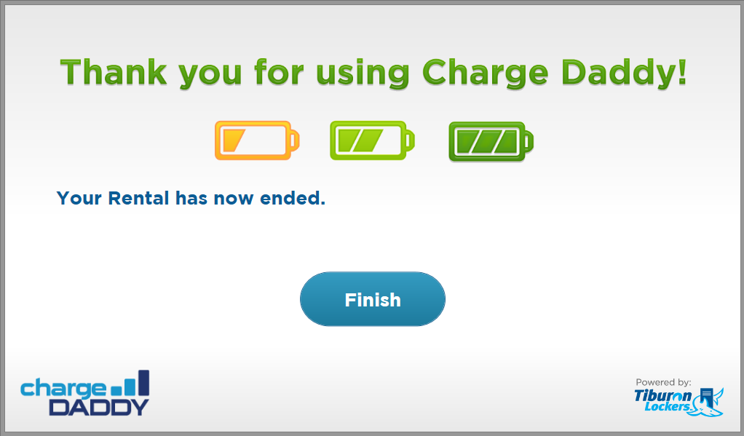
Figure 16: Single Access Rental End page

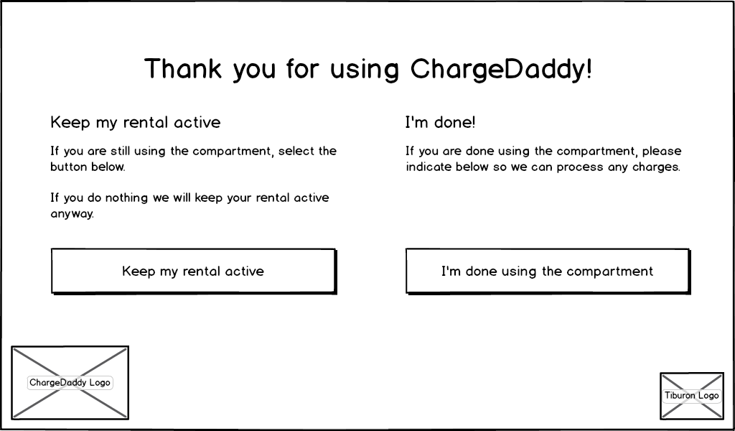
Figure 17: VIP, Hourly, & Multi-Day Rental End page

Action: | Ending the retrieval process
Description: | Occurs when the user rents chooses to retrieve device/ items.
Events: |  | The user clicks the Finish button.
 |  | The system displays the Screen Saver Page.
Alternate Path: | Rental is VIP, Hourly, or Multi-Day
 |  | The system hides the Finish button.
 |  | The system displays the option to keep the rental active or end it.
 |  | If the user opts to keep the rental active, they may return later and access the same compartment.
 |  | If the user opts to be “done” with the rental, the rental ends and the system makes that compartment available for other rentals.
 |  | The system displays the Screen Saver Page.

Action: | The Page Times Out
Description: | Occurs when the user doesn’t interact with the page within a timeout period.
Events: |  | The user leaves the page idle for the number of seconds configured in the “Time to make selections” setting on the Kiosk Timeouts tab.
 |  | The system displays the Screen Saver Page.
Notes: | If the rental type is not Single Access, the rental should remain active for that compartment.

Kiosk Application Secondary Monitor Pages

The following sections describe pages displayed in a secondary monitor if supporting hardware is present (VGA, DVI, HDMI) on the kiosk. These features are shared by Electronic Locker and ChargeDaddy except where explicitly noted.

Advertisement Rotator Page

This page is displayed to rotate through and display advertisements on a secondary monitor.
Action: | Advertisement Rotator
Description: | Displays advertisements on a secondary monitor
Pre-Conditions: | The secondary monitor advertisements were enabled in the Configure Advertising Page.
Events: |  | The secondary monitor rotates through advertisements placed in a specified folder location.
Assumptions: | A hardware monitor port is present and a secondary monitor is attached.

